Download BlueJ and Open Your First BlueJ Project

Course Programming Resources

The **BlueJ Environment**download, documentation, and programming resources are available at:

<http://www.dukelearntoprogram.com/course2/index.php>

(Note that if you have already downloaded a version of BlueJ, you will need to uninstall and download this one to get the edu.duke library.)

BlueJ has provided a [playlist of videos](https://www.youtube.com/watch?v=CPUaTT0Xoo4&list=PLYPWr4ErjcnzWB95MVvlKArO6PIfv1fHd) explaining some key Java terminology and how to use BlueJ.

Download BlueJ

From the above linked DukeLearnToProgram page, click on "Download BlueJ Environment" (<http://www.dukelearntoprogram.com/downloads/bluej.php>). Follow the relevant instructions for your device's operating system (Windows, Mac, or Linux). Note that on a Mac, you may want to move the BlueJ application to your "Applications" folder.

Also, for Mac users, if you get an alert when you try to open BlueJ for the first time that says, "BlueJ” can’t be opened because the identity of the developer cannot be confirmed," simply two-finger or right click on the BlueJ application icon and click "Open". You will still receive the same alert message, but now there will be a button in the alert that will allow you to open BlueJ. BlueJ should open normally without the alert after you open the application this first time.

If you intend to follow along with the *"Hello!" around the World* example showcased in the next video, download the project containing the example code from the DukeLearnToProgram Project Resources (<http://www.dukelearntoprogram.com/course2/files.php>, download **"BlueJ Project: HelloWorld class using FileResource**").

Opening BlueJ Project in Mac

The HelloWorld project contains these files in a zip folder:

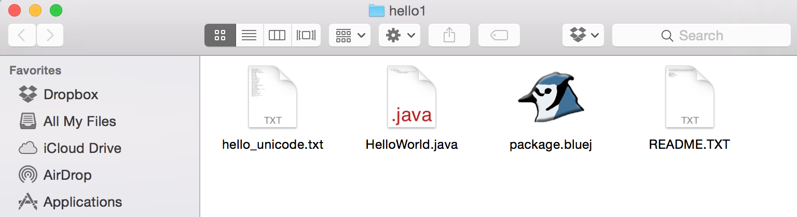

After downloading those files, open the BlueJ application, and from the menu bar, select Project -> Open Project. Select the project folder you have just downloaded, which should now have a BlueJ logo on the folder icon. Click "Open," and you are ready to compile and run the example program along with the next videos!

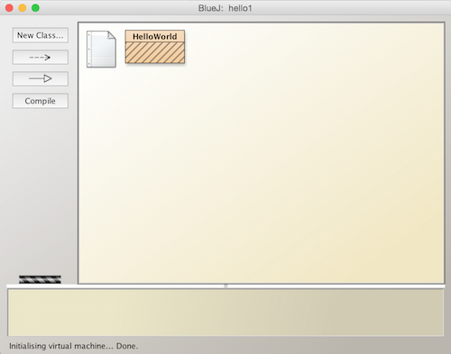

Opening BlueJ Project in Windows

The HelloWorld project contains these files in a zip folder:

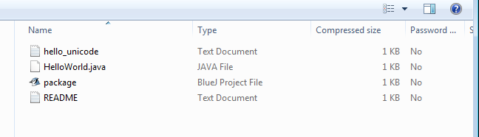

After downloading the zip folder, open the BlueJ application, and from the menu bar, select Project -> Open Project.

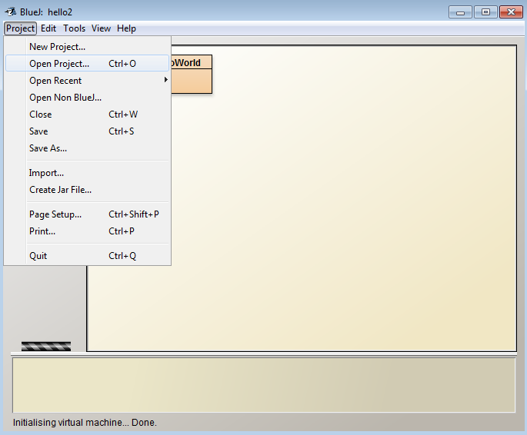

Select the zip folder you have just downloaded. Click "Open," and you are ready to compile and run the example program along with the next videos!

